**YEARLY REPORT**

ON

**“Empower people to take up their all round development into their own hands**

**(With special focus on Community Health, Education & Women Empowerment among the small & marginalized community in Gomia of Bokaro District, Jharkhand)**

**“Not what we say about our blessings, but how we use them, is the true measure of our thanksgiving”**

Preface:

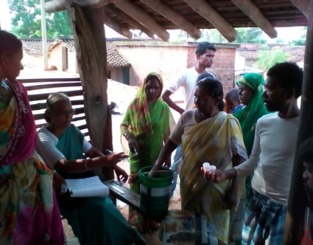India has more people with active TB disease than any other country in the world. Also millions individuals in India are now living with HIV/AIDS with HIV infection being recognized as the most potent risk factor progression from TB infection to active disease, the potential impact of the HIV epidemic on TB control in India is large.

We join hand with the Jharkhand Government with the theme of “Universal Access for quality diagnosis and treatment for all the TB patients in the community” with the target of “reaching the unreached”.

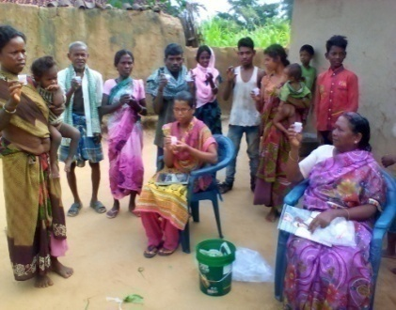Aiming the objective of Reducing the rampant TB and HIV/AIDS in the area, we are working tirelessly for marginalized communities by

**Sputum Test done in different villages**

timely diagnosis and treatment.

As usual, the work for the people suffering with TB and other related diseases, realizing this TB Health Care Centre is run by our organization. We have done sputum test in 10 villages among 1020 people, out of that 63 found as TB cases, 35 cases were found out as positive by sputum test and 28 are detected through X-ray test. These 63 TB and patients are admitted in our health centre for further treatment and they will be followed up very closely till they finish their TB treatment.

Alongside **513** patients came for other ailments i.e.fever, leucorrhoea, weakness, skin disease, ear pain etc.

We conducted six TB camps at the centre, where TB patients as well as other patients came for treatment. Every fortnight health talk is conducted for the TB patients as well as for the attendants about TB, HIV/AIDS, communicable diseases, cleanliness and intake of nutritious food etc.

Along with the treatment of TB, we screened our patients and relatives for hemoglobin (HB) test, which is the real root cause of inheriting the infectious diseases like - malaria, hepatitis, diabetes, TB, and anemia.

Poor nutrition is the most common and disabling health problem in different parts of India. Without enough good food, she /he could suffer from general poor health, including TB, exhaustion, weakness and anemia.

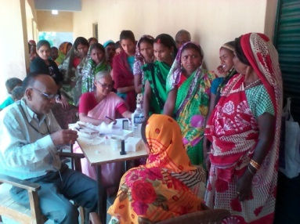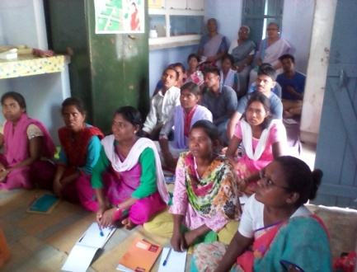We had conducted hemoglobin blood test camp in eleven villages for men & women for improving women’s health by increasing Hb to control anemia with the help of our ASK staff and Government staff along with health teaching. 631 of them were avail of our camp. We had found 43% people were below **8** Hb count. We had advised them to go to PHC in their own villages to be avail of

**Hb blood test carried out in different villages**

Government services or come to our health centre for further treatment. 7% of women

came to our centre for further treatment – like vitamins and iron tablets, herbal medicines, tonics etc. We were astonished to see the increase of Hb by 2 to 3 grams more within a month.

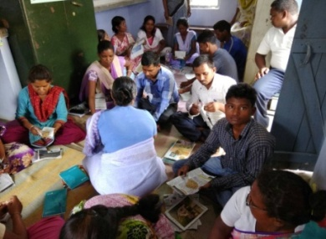**STAFF TRAINNING:** The said training was conducted on what is Anemia, how to detect Anemia, signs & symptoms of it & cause of Anemia for one self and in their own villages. Also explain to them the intake of nutritious items in their daily food. At the end of the seminar, we had distributed seeds of leafy vegetables to the staff as well to the people in the villages those who are in need to increase Hb. We have done the follow up of the seedlings and saw the people to add leafy vegetables in their food. We are glad to know that after our awareness programme many women went to the market and they too brought seeds and seedlings to cultivate and add leafy vegetables in their food.

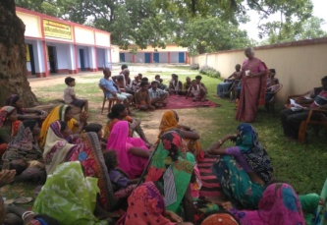

**COMMUNITY HEALTH**

The whole world is looking for some kind of structural changes for Justice, Peace, Prosperity & melodious life. we tried to extend our work to respond to the call of the time. The work of the women section - saving and credit is going on as usual. As women get busy in the field in monsoon season from mid July to mid August staff was busy in auditing their accounts in the centre.

**LEADERSHIP AND CAPACITY BUILDING TRAINING**

Jharkhand Government had passed the bill for the amendment of the CNT /SPT (Chotanagpur Tenancy Act and Santhal Pargana Tenancy Act) in the month of February 2017 in three minutes. These both Acts are the Constitutional protection measures for the Tribal land. This Amendment would change the nature of the land; Adivasis (Tribal) land will change into the non-agricultural land.

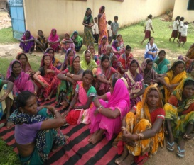It means Land Alienation of the Tribes is sure. Staff were busy with orientation meetings and awareness workshops/seminars on CNT/SPT Act (Chotanagpur Tenancy Act and Santhal Pargana Tenancy Act) along with ST/SC/OBC (scheduled Tribe/Scheduled Caste/ Other Backward Castes) Reservation bill. We organized altogether Fifteen (15) workshops in these months to protect these Rights of the Tribes’ land. Nearly forty (40) villages we could cover.

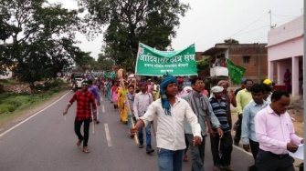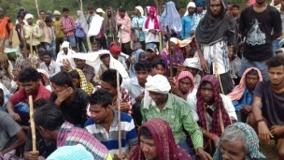 **PARTICIPATION IN PROTEST MARCH:**  On Rights of the Tribes’ land. We had big rallies in two blocks Gomia and Nawadih on 20th of May and 20th of June & July 2017 respectively. Quite a good number of Tribal joined in these Rallies organized by ABUSSAL(Adivasi Bahuddesiya Uthan Sahkari Samiti –means Tribal multi-purpose development cooperative Society) and ACS(Adivasi Chater Sangh – means Tribal Student Union) the Tribal non- Political Organizations. In all these rallies Memorandums were given to BDOs,(Block Development officer) District Magistrates and also to the Governor of Jharkhand. Now Governor of Jharkhand Mrs. Drawpadi Murmu has sent this bill back.

**DHAMDRWA PROTEST -DHARNA**

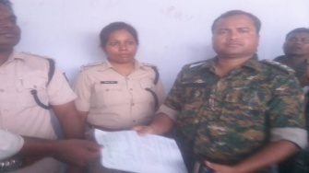There is a beautiful thing happened because of these workshops and seminars. During these days a village called Dhamdrwa in Gomia block itself Police came to raid the village, caught two men from their houses and took them to the jungle and beaten them up and saying that they are MCC (Maoist communist committee) extremist. Women also are beaten as they were protesting these men. The villagers came together and opened the Protest Rally against the Administration- the Police 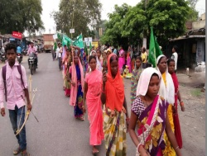at Dumbri Bihar where there is a picket. Within a week, protest Dharna was organized at Block level. The District administration was alert.

The DSP (District Superintendent of Police) accepted the Memorandum after a long discussion on the 19 of July2017.

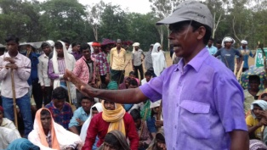The eye of the present Government is on the land of Jharkhand which is rich in Jungle, water, minerals and for cheap lab our. In spite of all these, people are seasonal migrants, uneducated and poor. This needs a lot of awareness and a strong combined action plan in different levels.

We can see our effort and networking have brought a lot of awareness among villagers. They know to some extent their rights and duties towards their society. We see it a successful event in Gomia’s History.

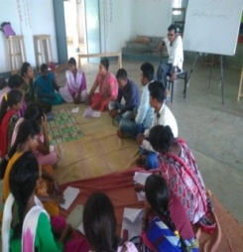

**SELF HELP GROUPS**: - All through the months along with different programs the savings of the women’s group was continued in all the villages. ASK has 62 groups in 25 villages in four blocks in two districts still. State Rural Livelihood Mission (SRLM) designated by the Govt. of Jharkhand for implementing National Rural Livelihood Mission (NRLM) is over all coordinator and Monitor and also a nodal agency for implementation of all skill development programme which is known as JSLPS Jharkhand State Livelihood Promotion Society (JSLPS) Government of Jharkhand.

The Agency is promoting SHGs in all the villages of Jharkhand called **Sakhi Mandals** and also linking them with all the services of Government for SHGs. There is staff working in all the villages in the groups. The SHGs are getting attracted to these facilities and at the same time there is no other option, we have decided to link our groups to this Government Program. On our part we are there to help and guide them not to get trapped in Government loans as before it had happened. We need to study more in this matter and plan strategically to accompany women in our area.

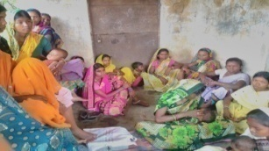**TRAINING AND EXPOSURE ON SHG (SELF HELP GROUPS) AND CO-OPERATIVE BANK (7- 9TH OF SEPT/2017): -THIS WAS HELD IN JAN VIKAS KENDRA-JAMSEDHPUR**. We have two days of Theory and a day for exposure to the close by Cooperatives. We learned the concept of SHG Cluster and Cooperative bank, the Administrative structure, small credit, finance system and helping in capacity building needs. **12** women attended this program. The Cooperative is not only financial purpose but also bringing women in one fold for social upliftment.

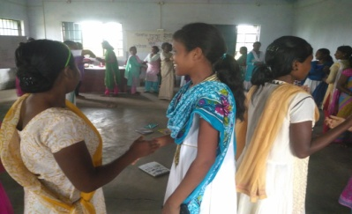**YOUTH LEADERSHIP SEMINAR (22ND AND 23RD OF SEPT/2017)**

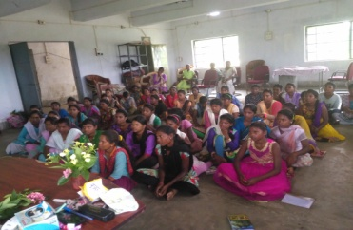Today the youth is feeling hopeless & confused of direction in their life. They are becoming the victims of the pathetic society. Young women are the target of revenge of any kind of disturbances in the society here. It is a big concern for the society. Forty six young women participated in this seminar. The Theme was ‘**who am I?’** Capacitate them with knowledge about their Self Identity, their culture, their land, Health – Hygine and their Rights were the focus points. Mr.Shashi Kant Kujur, Mr. Philan Horo and Elizabeth from Health section of our Asha Seva Kendra helped on different themes through different charts, games, discussion, songs and lectures. This seminar was very enlightening, entertaining and with lots of convictions that they are the leaders of the time and have responsibility towards society. **52** young girls from different villages took part in it.

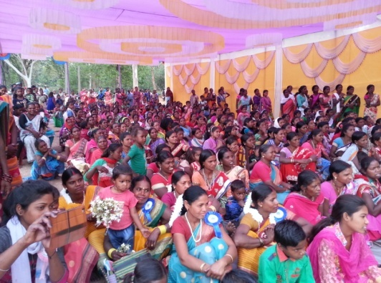

**WOMEN’S DAY CELEBRATION**

The 15th March 2018 ASHA SEVA KENDRA –GOMIA celebrated International Women’s Day as the Day of Rights of Tribal, OBC, Dalits, and Marginalized .

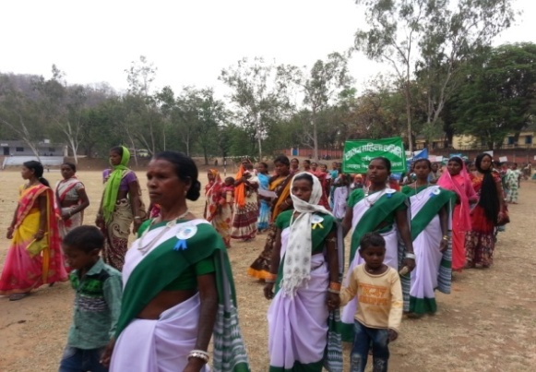Nearly 800 women Participated in this occasion. Women led the Rally with the slogans and drums through Block office to I.E.L. Ground. On this occasion a Renowned Tribal women Activist named-Mrs. Dayamani Barla from Ranchi, upcoming two young tribal Activists Pramodh Murmu and Duraga Pawria the honorable guests of the day were present.

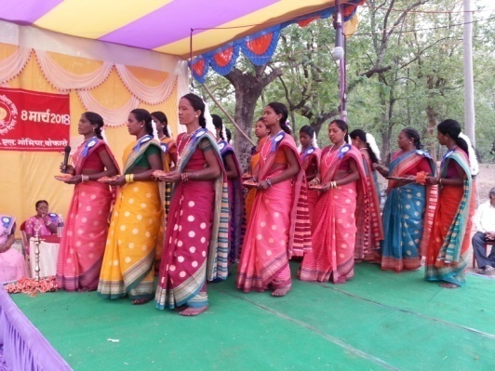Mrs. Dayamani enlightened the women and men present on this occasion by giving a details of events where Tribal women along with men counterpart fought in Chotanagpur since the British Rule, which is not mentioned in history only because they are tribal. She also threw the light on the situation of Tribals today. She explained how the Rights of Tribals, Backward class, Dalits and Marginalized people denied in the name of Amendments of the Acts which protect the rights of the people, Especially the Land Rights. She focused how the present government is using different strategies to break the unity of the Tribes, Dalits and minorities in the name of caste, creed, place and language. Women not only enlightened with motivational talks and speeches but also enjoyed with cultural flock dances, motivational songs etc. It was very enjoyable and enlightening day for women. The Women’s Day Celebration was called off after the thanks giving speech by Sr. Stella followed by Lunch for everyone.

**ACHIEVEMENTS:**

* Through SHGs the village meeting /workshop (CNT/SPT Act (Chotanagpur Tenancy Act and Santhal Pargana Tenancy Act)) were held in different village was successful. Many villagers attended and taken interest in social issues and participated in protest rally of the group by themselves.
* Women those who attended the training are convinced to have the women’s Cooperative.
* Networking with other organization was a successful effort. The Amendment of Chotanagpur Tenancy Act and Santhal Pargana Tenancy Act is withdrawn a big success for whole Jharkhand’s Tribes.
* Villagers gone for Protest March and Dharna against injustice towards Tribal is the sign of the unity and strength and conviction.
* A rally for Tribal Rape case (Dumka-Abhaya case) and protection of Rights of Gram Sabah (Vth Scheduled of Constitution) is a sign of their sensitivity and duty towards the society.

**CHALLENGES**

* Difficult to make women learn read and write. And thus to make them do their daily savings and credit.
* The SHGs(Self Help Groups) members got diverted and also divided because of the new groups promoted by the Jharkhand State Livelihoods Promotion Society (JSLPS) –the government.
* Work in the field and office become heavy as staffs discontinue the job.
* It is still hard work to bring women out of house for training, exposure either in the centre or outside.
* The difficult political situation makes people more vulnerable and institute weak.

**NON FORMAL EDUCATION**

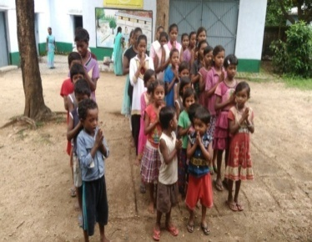This school year the education activities are conducted to thirteen centres. The students come to the centers with joy together to learn with their friends. The centres give another atmosphere to learn, different teacher and different companions from different schools. The study centre not only gives knowledge to the students but also adds happiness in their lives.

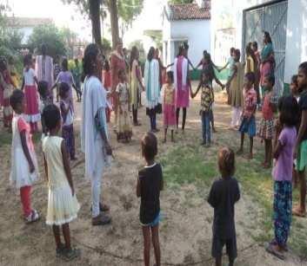It is sad to say that we have closed two centers due to the poor attendance of the children; kaswagada was closed in the month of July and Jahar tola in the month of August. At present we have eleven centres functioning with twelve teachers and the supervisor. We are looking for possibilities of opening in other villages. We need some time to study which village we could open. At the time of plantation some of the students were absent because they have to take their cows for grazing while the parents are busy in the fields.

Everyday students learn Mathematics, Hindi, science and English, especially the subject that they find it difficult. On Saturdays they do the extracurricular activity, which is games, songs, drawing readings etc.

**ECOLOGY DAY CELEBRATION**

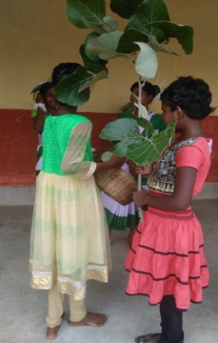On June 5th was the ecology day. As we do not have the place to celebrate it together, the centers were made in to **4** clusters. Each cluster has prepared it very beautifully, opening with a prayer, lighting the candle to invoke God. In this celebration the student show their talents through dance, drama, speech on ecology. All their programme were very beautiful, where we can understand and feel that they have grasp the very problem of ecology and the desire to care for it, to plant more trees in their villages, to enjoy the fresh air and less sickness. They also said that more trees mean possibilities to have more rain. The head of the village also gave speech on ecology, how to care for the surroundings, which was an encouragement for the children. They enjoyed coming together to perform their abilities that they can dance and sing. **218** children took part in it directly and their parents were there too.

**ESSAY WRITING**

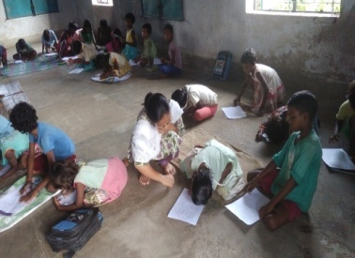In the month of July we had the competition on essay writing. The theme was “My ambition in life”. The students were divided in two groups according to the class IV, V, VI were in one group and class VII and VIII in another group. First they wrote in their own centers and then from every centre two persons were chosen to join in the contest and wrote in their cluster area. Anima Soreng a Principal from a Government school was the one to correct it. Many of them have written that they want to be a teacher to study well and one day they can be a teacher to help other poor students. One of the students wrote that his desire is to be a doctor; he says “I may or I may not be, but I have the desire.” When his father was sick he was admitted in Asha Seva Kendra and he was cured. When he himself was sick parents brought him to the dispensary. He admires the work of the sisters how they help the poor people. This has motivated him to help others specially the sick and the poor. **22** children participated in **Essay** writing. From both the groups the best ones are numbered in first second and third and the prices will be distributed on Children’s Day in November.

**ABILITY TEST & EXAM**

In the month of August we conducted exam for the students on Math Hindi and English. It is to know how much the students are learning and improving, and where the teachers have to pay more attention. Exam also helps the students to study more and better. The students were grouped ,as group A - from class 1 to 2, group B from class 3 and 4, group C from class 5 and 6, group D from class 7and 8. **243** From every group first, second third will be honored on Children’s Day in November.

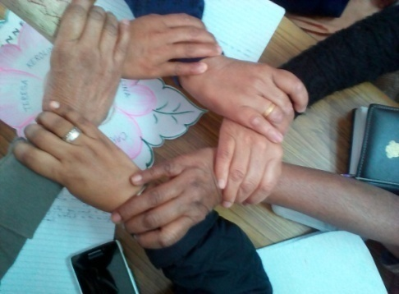

Our sincere thanks to Bodhgaya Development Association for your valuable contribution, and support, very especially contribution towards the new building of Community Health Care Centre. With your support, we have made a tremendous difference in the lives of the people, especially Children, women and patients. We are blessed by your timely support.

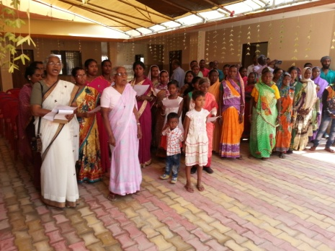

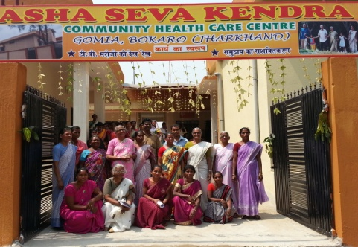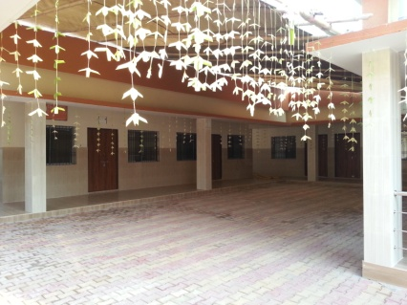

**Sr. Louise Mary,**

**09/04/2018**